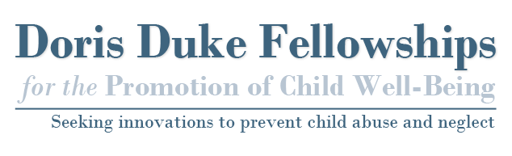
Letter of Commitment Instructions
Thanks to the generous support of the Doris Duke Charitable Foundation, Chapin Hall at the University of Chicago is pleased to offer the Doris Duke Fellowships for the Promotion of Child Well-Being. These fellowships are designed to identify and develop a new generation of leaders interested in and capable of creating practice and policy initiatives that will enhance child development and improve the nation's ability to prevent all forms of child maltreatment.

We ask that all applicants to the Doris Duke Fellowships for the Promotion of Child Well-Being obtain a letter of commitment from the dean or chair of their doctoral program outlining the specific resources and supports the institution provides its doctoral students. This letter must be on university letterhead and signed by the dean or department head.
The letter of commitment should address the following:
- How does your school or department support its doctoral students?
- Is the applicant in good standing?
- It is our expectation that receipt of the fellowship will not impact a student’s access to current support they are receiving from their host university with respect to tuition waivers and health care coverage. In your letter of commitment, please address this issue.
Please email completed letters to ddfellowships@chapinhall.org. Documents should be saved in .doc, .docx, or .pdf format. The file name should be in the following format: Applicant Name-Commitment Letter 2016.doc. The applicant may submit this letter on behalf of the dean.

If you would like additional information on the fellowship or have any questions, please email ddfellowships@chapinhall.org or visit our website at www.dorisdukefellowships.org.

